Dashboard UI Configuration

Purpose of this document is to provide guidelines for our partners & customers to configure dashboard UI. Current process is to communicate the needed changes to the support team but partners and customers have requested greater flexibility to do such changes. The document provides the UI components supported by Reltio on Dashboard, properties of such components and examples for configurators to follow. Please note that customers & partners still have to follow the process to get the UI configuration file via support and deployment of changes to UI will continue to be done by support. Any changes done by customers or partners should be done carefully and responsibly.

Table of Content

Dashboard Configuration Process 4
Perspective & Layout 5
Properties 5
Layout Properties 5
Example 6
Simple Views 8
Profile Stats View 8
Properties 8
Example 8
Activities View 9
Properties 9
Example 10
Bar Chart View 10
Properties 11
Example 12
Bubble Chart View 13
Properties 13
Example 14
Entities by Role View 15
Properties 15
Example 16
Entities by Tag View 16
Properties 16
Example 17
Entities by Type View 18
Properties 18
Example 18
Map View 19
Properties 19
Example 21
Notification Inbox View 22
Properties 22
Example 22
Filtered Entities View 23
Properties 23
Example 24
Advanced Views 26
Facet Chart View 26
Properties 26
Chart Options 28
Example 33
Simple Map View 35
Properties 35
Chart Options 37
Example 40

Dashboard Configuration Process
- Please raise a zendesk ticket to get the Dashboard configuration for a particular tenant. Please note that configuration needs to be modified and deployed to individual tenants - dev, test & prod. Change of config in one tenant does not reflect automatically in others.
- Support team to provide the dashboard configuration JSON file via the same ticket
- Customer/Partner make the change to the configuration
- Pass on the Dashboard configuration json back to the support team via ticket to get it deployed. Please note - For the changes done to configuration done by customers and partners, the support team will just deploy the changes and not validate it. Partner/customer will be responsible for the changes done.

Perspective & Layout
The perspective configuration is used to describe what views should be on the dashboard. Please, use examples as a basic configuration and modify only “center” and “right” properties.

Properties
Name | Type | Description
point | String | "com.reltio.plugins.ui.perspective"
id | String | "com.reltio.plugins.dashboard.DashboardPerspective"
class | String | "com.reltio.plugins.ui.Perspective".
layout | Object | Describes views position (see “Layout Properties”).

Layout Properties
Name | Type | Description
layout | String | "dashboard"
center | Array.<(String|Object)> | list of views located on center of screen. Item can be a String with a view ID or an object with the following properties:  Name Type Description  left String view id to show on left column of center block.  right String view id to show on right column of center block.  (optional)
right | Array.<String> | list of views located on right side of screen (optional).

Example
{
"id": "com.reltio.plugins.dashboard",
"name": "Dashboard Perspective",
"version": "1.0.0",
"provider-name": "Reltio.com",
"requirements": [
"com.reltio.plugins.entity"
],
"extensions": [
{
"point": "com.reltio.plugins.ui.perspective",
"id": "com.reltio.plugins.dashboard.DashboardPerspective",
"class": "com.reltio.plugins.ui.Perspective",
"layout": {
"layout": "dashboard",
"center": [
"com.reltio.plugins.dashboard.ProfileStatsView",
{
"left": "com.reltio.plugins.dashboard.BarIntNested",
"right": "com.reltio.plugins.dashboard.HCPByCustomerType"
},
{
"left": "com.reltio.plugins.dashboard.HCAByStatus",
"right": "com.reltio.plugins.dashboard.HCPByStatus"
},
{
"right": "com.reltio.plugins.dashboard.LookupFileBasedSearch"
}
],
"right": [
"com.reltio.plugins.notifications.Inbox",
"com.reltio.plugins.activities.ActivitiesView"
]
}
},
// Place for facet configurations
]
}

Simple Views

Profile Stats View

Profile Stats View shows entity statistics on a tenant.

Properties

Name | Type | Description
point | String | "com.reltio.plugins.ui.view"
id | String | unique extension id. Example: "com.reltio.plugins.dashboard.ProfileStatsView".
class | String | "com.reltio.plugins.dashboard.ProfileStatsView"
caption | String | view's title on view's header (optional).

Example
{
"point": "com.reltio.plugins.ui.view",
"id": "com.reltio.plugins.dashboard.ProfileStatsView",
"class": "com.reltio.plugins.dashboard.ProfileStatsView",
"caption": "Profile Stats"
}
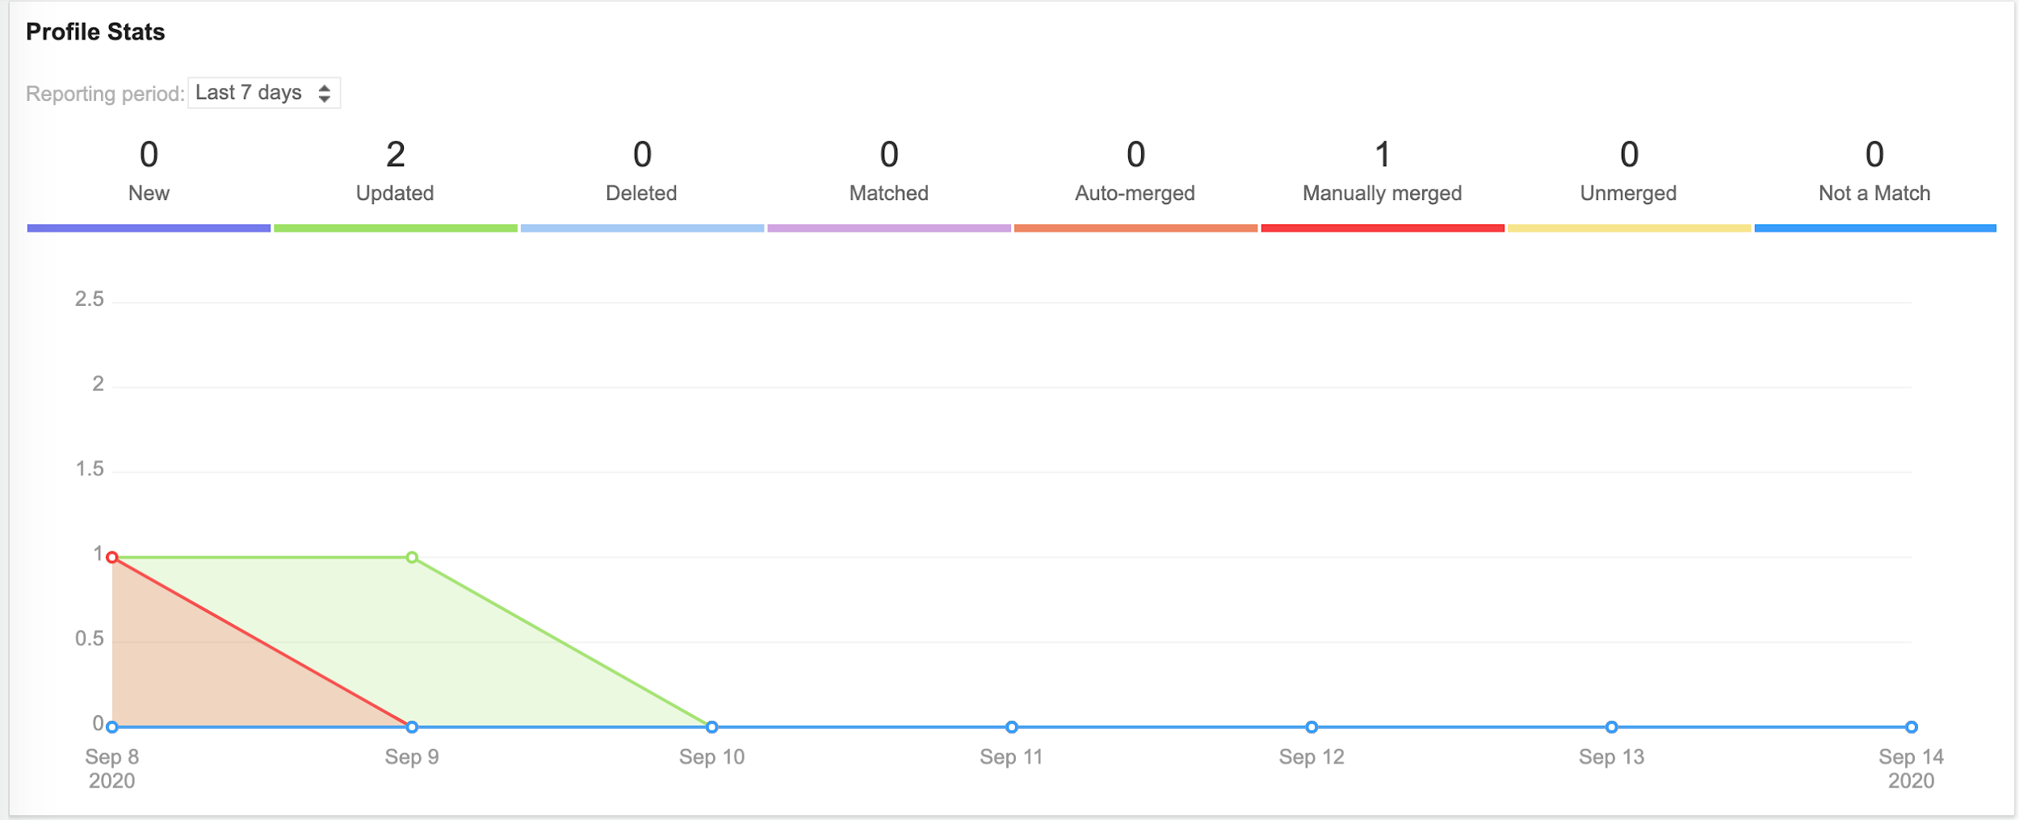

Activities View
Activities View shows user activities on tenant. Usually it is already configured in file com.reltio.plugins.activities.json

Properties
Name | Type | Description
point | String | "com.reltio.plugins.ui.view".
id | String | unique extension id. Example: "com.reltio.plugins.activities.ActivitiesView".
class | String | "com.reltio.plugins.activities.ActivitiesView"
caption | String | view's title on view's header (optional).
activitiesOnPage | Number | number of activities on page (optional).
itemsOnActivity | Number | number of items on activity (optional).
deltasOnItem | Number | number of detail items on activity item (optional).
text-empty | String | text on view when no activities were found (optional).

Example
{
"point": "com.reltio.plugins.ui.view",
"id": "com.reltio.plugins.activities.ActivitiesView",
"class": "com.reltio.plugins.activities.ActivitiesView",
"caption": "Activity log",
"activitiesOnPage": 25,
"itemsOnActivity": 20,
"deltasOnItem": 3
}
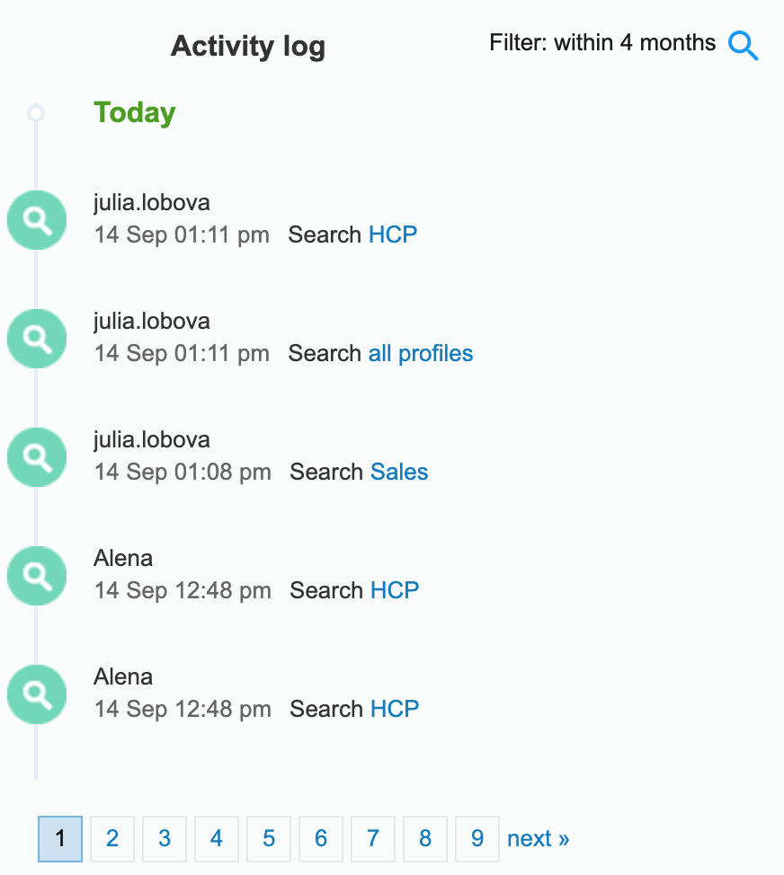

Bar Chart View

Bar Chart View is a view with a bar chart (see d3.js bar chart). It sends _facet requests to get data from Reltio API.

Properties
Name | Type | Description
point | String | "com.reltio.plugins.ui.view".
id | String | unique extension id. Example: "com.reltio.plugins.dashboard.BarChartView".
class | String | "com.reltio.plugins.dashboard.BarChartView"
entity | String | entity type URI. Chart is made for this type. Example: "configuration/entityTypes/HCP".
attribute | String | id ("attributes.[attributeName]"). Example: "attributes.Identifiers.Type".
filter | Array.<Object> | filter configuration (optional). Example:  [{  "type": "equals",  "attribute": "attributes.Phone.ValidationStatus",  "value": "VALID"  }]  Name Type Description  type String filter function (standard filters can be used). Example: "equals".  attribute String attribute id ("attributes.[attributeName]"). Example: "attributes.Phone.ValidationStatus".  value String | Number |Boolean attribute value. Example: "VALID".
count | Number | number of elements on chart (optional).
orderType | String | order of elements on chart. Example: "reversedCount" (optional).
caption | String | view's title on view's header (optional).

Example
{
"point": "com.reltio.plugins.ui.view",
"id": "com.reltio.plugins.dashboard.HCPBySpeciality",
"class": "com.reltio.plugins.dashboard.BarChartView",
"caption": "Active HCPs by Active Primary Specialty",
"entity": "configuration/entityTypes/HCP",
"attribute": "attributes.Specialities.Specialty",
"filter": [
{
"type": "equals",
"attribute": "attributes.Specialities.PrimarySpecialityInd",
"value": true
},
{
"type": "equals",
"attribute": "attributes.Specialities.SpecialityStatus",
"value": "ACTI"
}
],
"count": 10
}
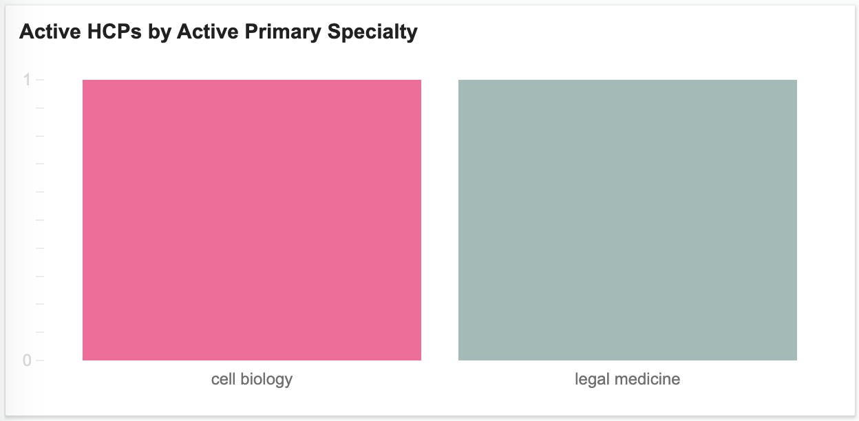

Bubble Chart View

Bubble Chart View is a view with bubble chart (see d3.js bubble chart). It sends _facet request to get data from Reltio API.

Properties
Name | Type | Description
point | String | "com.reltio.plugins.ui.view".
id | String | unique extension id. Example: "com.reltio.plugins.dashboard.BubbleChartView".
class | String | "com.reltio.plugins.dashboard.BubbleChartView"
entity | String | entity type URI. Chart is made for this type. Example: "configuration/entityTypes/HCP".
attribute | String | id ("attributes.[attributeName]"). Example: "attributes.Identifiers.Type".
filter | Array.<Object> | filter configuration (optional). Example:  [{  "type": "equals",  "attribute": "attributes.Phone.ValidationStatus",  "value": "VALID"  }]  Name Type Description  type String filter function (standard filters can be used). Example: "equals".  attribute String attribute id ("attributes.[attributeName]"). Example: "attributes.Phone.ValidationStatus".  value String | Number |Boolean attribute value. Example: "VALID".
count | Number | number of elements on chart (optional).
orderType | String | order of elements on chart (optional). Example: "reversedCount".
caption | String | view's title on view's header(optional).

Example
{
"point": "com.reltio.plugins.ui.view",
"id": "com.reltio.plugins.dashboard.LocationbyCountryView",
"class": "com.reltio.plugins.dashboard.BubbleChartView",
"caption": "International Location Distribution IN",
"entity": "configuration/entityTypes/HCP",
"attribute": "attributes.CountryCode",
"filter": [{
"type": "in",
"attribute": "attributes.CountryCode",
"value": ["US", "PT"]
}]
}
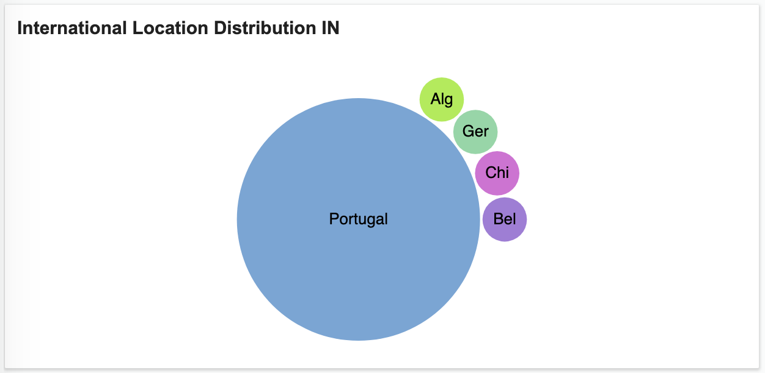

Entities by Role View

Entities by Role View is a view with entity roles on treemap chart (see d3.js treemap chart)

Properties
Name | Type | Description
point | String | "com.reltio.plugins.ui.view".
id | String | unique extension id. Example: "com.reltio.plugins.dashboard.EntitiesByRoleView".
class | String | "com.reltio.plugins.dashboard.EntitiesByRoleView"
hideEmpty | Boolean | hide items with zero count (optional).
orderType | String | order of elements on chart (optional). Example: "reversedCount".
caption | String | view's title on view's header (optional).

Example
{
"point": "com.reltio.plugins.ui.view",
"id": "com.reltio.plugins.dashboard.EntitiesByRoleView",
"class": "com.reltio.plugins.dashboard.EntitiesByRoleView",
"caption": "Profile Roles",
"hideEmpty": true
}
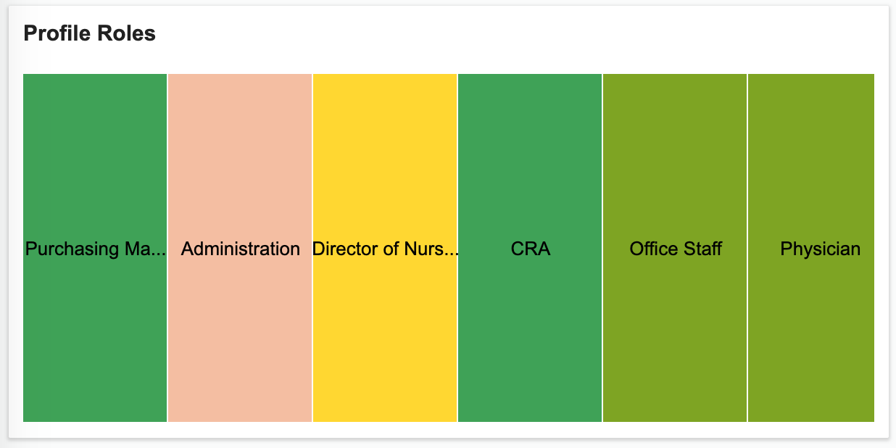

Entities by Tag View

Entities by Tag View is a view with entity tags on word cloud chart (see d3.js word cloud chart)

Properties
Name | Type | Description
point | String | "com.reltio.plugins.ui.view".
id | String | unique extension id. Example: "com.reltio.plugins.dashboard.EntitiesByTagView".
class | String | "com.reltio.plugins.dashboard.EntitiesByTagView"
orderType | String | order of elements on chart (optional). Example: "reversedCount".
caption | String | view's title on view's header (optional).

Example
{
"point": "com.reltio.plugins.ui.view",
"id": "com.reltio.plugins.dashboard.EntitiesByTagView",
"class": "com.reltio.plugins.dashboard.EntitiesByTagView",
"caption": "Profile Tags"
}

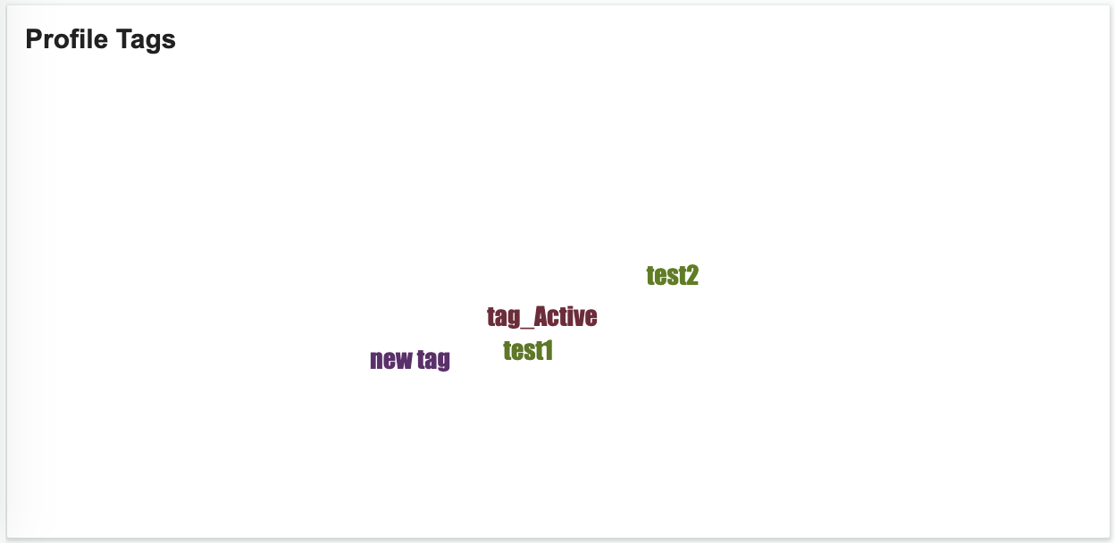

Entities by Type View

Entities by Type View is a view with entity types on treemap chart (see d3.js treemap chart).

Properties
Name | Type | Description
point | String | "com.reltio.plugins.ui.view".
id | String | unique extension id. Example: "com.reltio.plugins.dashboard.EntitiesByTypeView".
class | String | "com.reltio.plugins.dashboard.EntitiesByTypeView"
hideEmpty | Boolean | hide items with zero count (optional).
orderType | String | order of elements on chart (optional). Example: "reversedCount".
caption | String | view's title on view's header (optional).

Example
{
"point": "com.reltio.plugins.ui.view",
"id": "com.reltio.plugins.dashboard.EntitiesByTypeView",
"class": "com.reltio.plugins.dashboard.EntitiesByTypeView",
"caption": "Profile Types",
"hideEmpty": true
}

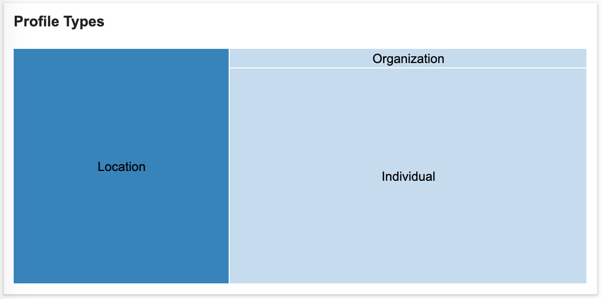

Map View

MapView is a view with USA (by state, county or zip) or world map.

Properties
Name | Type | Description
point | String | "com.reltio.plugins.ui.view".
id | String | unique extension id. Example: "com.reltio.plugins.dashboard.MapView".
class | String | "com.reltio.plugins.dashboard.MapView"
entity | String | entity type URI. Chart is made for this type. Example: "configuration/entityTypes/HCP".
attribute | String | id ("attributes.[attributeName]"). Example: "attributes.Address.StateProvince".
filter | Array.<Object> | filter configuration (optional). Example:  [{  "type": "equals",  "attribute": "attributes.Phone.ValidationStatus",  "value": "VALID"  }]  Name Type Description  type String filter function (standard filters can be used). Example: "equals".  attribute String attribute id ("attributes.[attributeName]"). Example: "attributes.Phone.ValidationStatus".  value String | Number |Boolean attribute value. Example: "VALID".
mapType | Number | map type (optional):  - 0: world  - 1: USA by state  - 2: USA by county  - 3: USA by zip
strokeColor | String | map's stroke color (optional).
backgroundColor | String | map's background color (optional).
startColor | String | map palette's start color (optional).
endColor | String | map palette's end color (optional).
allowMoveMap | Boolean | allow move map by mouse (optional).
allowZoom | Boolean | allow zoom map by mouse wheel (optional).
orderType | String | order of elements on chart (optional). Example: "reversedCount".
caption | String | view's title on view's header (optional).

Example
{
"point": "com.reltio.plugins.ui.view",
"id": "com.reltio.plugins.dashboard.HCPCountView",
"class": "com.reltio.plugins.dashboard.MapView",
"caption": "HCP Count",
"startColor": "#D6F1FF",
"backgroundColor": "#dddded",
"endColor": "#007ac1",
"entity": "configuration/entityTypes/HCP",
"attribute": "attributes.Address.StateProvince"
}

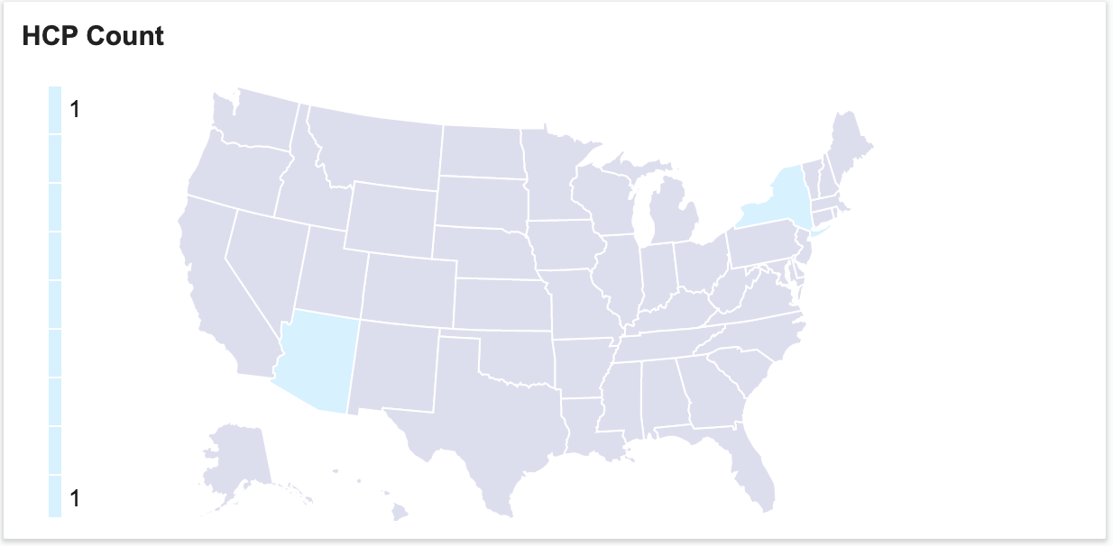

Notification Inbox View

NotificationInboxView is a view with a pageable list of workflow engine notifications.

Properties
Name | Type | Description
point | String | "com.reltio.plugins.ui.view".
id | String | unique extension id. Example: "com.reltio.plugins.notifications.Inbox".
class | String | "com.reltio.plugins.inbox.NotificationInboxView"
pageSize | Number | number of elements on a page (optional).
showFilter | Boolean | show filter control (optional).
caption | String | view's title on view's header (optional).

Example
{
"point": "com.reltio.plugins.ui.view",
"id": "com.reltio.plugins.notifications.Inbox",
"class": "com.reltio.plugins.inbox.NotificationInboxView",
"showFilter": true
}

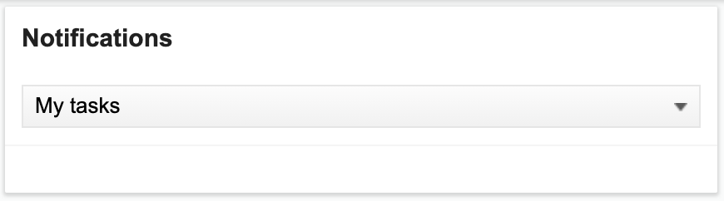

Filtered Entities View

Filtered Entities View is a view with a pageable list of entity search results.

Properties
Name | Type | Description
point | String | "com.reltio.plugins.ui.view".
id | String | unique extension id. Example: "com.reltio.plugins.dashboard.FilteredEntitiesView".
class | String | "com.reltio.plugins.dashboard.FilteredEntitiesView"
entity | String | entity type URI. Chart is made for this type. Example: "configuration/entityTypes/HCP".
filter | Array.<Object> | filter configuration (optional). Example:  [{  "type": "equals",  "attribute": "attributes.Phone.ValidationStatus",  "value": "VALID"  }]  Name Type Description  type String filter function (standard filters can be used). Example: "equals".  attribute String attribute id ("attributes.[attributeName]"). Example: "attributes.Phone.ValidationStatus".  value String | Number |Boolean attribute value. Example: "VALID".
max | Number | number of elements on a page (optional).
text-empty | String | text on view when no entities were found (optional).
caption | String | view's title on view's header (optional).

Example
{
"point": "com.reltio.plugins.ui.view",
"id": "com.reltio.plugins.dashboard.FilteredEntitiesView",
"class": "com.reltio.plugins.dashboard.FilteredEntitiesView",
"caption": "HCPs in USA",
"entity": "configuration/entityTypes/HCP",
"filter": [{
"type": "equals",
"attribute": "attributes.AddressNested.Country",
"value": "US"
}]
}

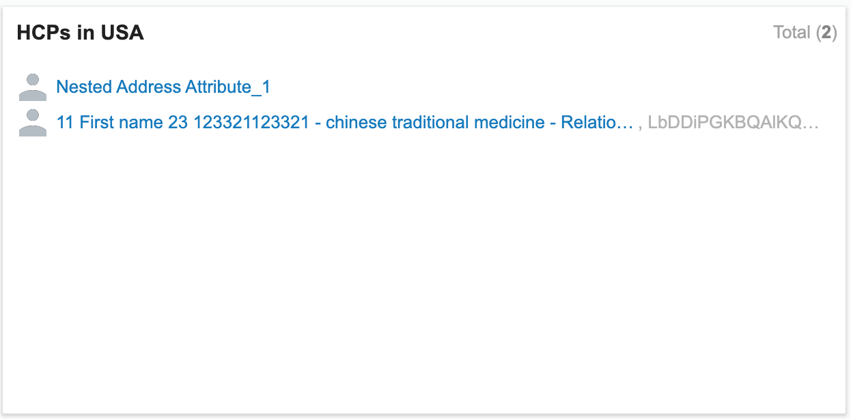

Advanced Views

Facet Chart View

Facet Chart View is a view with specific facet values chart (bar chart - vertical and horizontal, line chart, map and pie chart).

Properties
Name | Type | Description
point | String | id of Extension Point which describes current extension. Must be: "com.reltio.plugins.ui.view".
id | String | unique extension id. Example: "com.reltio.plugins.dashboard.FacetChartView".
class | String | javascript class: "com.reltio.plugins.dashboard.FacetChartView"
height | Number | height of a view (optional, default value: 300).
filter | Array.<Object> | filter configuration (optional). Example:  [{  "type": "equals",  "attribute": "attributes.Phone.ValidationStatus",  "value": "VALID"  }]  Name Type Description  type String filter function (standard filters can be used). Example: "equals".  attribute String attribute id ("attributes.[attributeName]"). Example: "attributes.Phone.ValidationStatus".  value String | Number |Boolean attribute value. Example: "VALID".
count | Number | number of elements on chart (optional).
firstDimension | String | label source (optional). Example: "businessProcessData.tasks.taskName".
colorPalette | String | name of predefined color palette (optional, default value: "default"). Options: "random0", "random1", "spectreYellowCyan", "spectreBlueBrown", "default".
options |  | chart options, see description below (optional).
presentation | Object | configuration of attribute value presentation (optional).  Name Type Description  format String specify attribute formatting. The only possible format now is "none".
caption | String | view's title on view's header (optional).

Chart Options

Name | Type | Description
chartId | String | chart type. Options:  - "BarChart": simple bar chart is designed to work with 2-dimensional datasets, where each item should have unique firstDimension value. If the firstDimension is non-unique across items, then the integration occurs.  - "BarChartGrouped": BarChart with groups.  - "BarChartHorizontal": BarChartGrouped with horizontal bars.  - "LineChart": same as BarChart, but represents data with line chart.  - "Map": map view.  - "Pie": pie chart.
width | Number | the width of the area in pixels, this includes everything - the chart itself, its legend, etc. (optional)
height | Number | the height of the area in pixels, this includes everything - the chart itself, its legend, etc. (optional)
chartWidth | Number | area which is to be occupied solely by chart (optional).
chartHeight | Number | area which is to be occupied solely by chart (optional).
chartPadding | Object | padding inside the Chart Client area (optional). Top padding is used to fit bar super-scripts. Example: {"top": 20, "right": 0, "bottom": 45, "left": 40}.  Name Type Description  top Number chart's top padding.  right Number chart's right padding.  bottom Number chart's bottom padding.  left Number chart's left padding.
minColumnWidth | Number | If you specify this parameter, the column width will be restricted. If you do not specify it, the column width is to be picked automatically which ensures that entire dataset is fit into visible area. Example: 24. (optional)
maxColumnWidth | Number | If you specify this parameter, the column width will be restricted. If you do not specify it, the column width is to be picked automatically which ensures that entire dataset is fit into visible area. Example: 24. (optional)
bandSpacing | Number | defines spacing between columns as a fraction of column width. Example: 0.25 (optional)
scaleAlign | String | align on scale. Options: "left", "center". (optional)
allowPan | Boolean | availability of panning function. (optional)
allowNavBar | Boolean | availability of Navigation bar, which may be shown only if the data does not fit into visible area. (optional)
navBarPadding | Object | the Navigation bar client area is positioned straight below the chart, but padding inside of it can be specified. (optional)  Name Type Description  top Number navigation bar's top padding.  right Number navigation bar's right padding.  bottom Number navigation bar's bottom padding.  left Number navigation bar's left padding.
navBarHeight | Number | navigation bar's height (should be the same or bigger than the sum of vertical padings).
showLegend | Boolean | chart's legend (optional).
legendAnchorPoint | Array.<Number> | anchor point for the legend. Make sure it does not overlap the chart, by also specifying chartWidth and chartHeight. Example: [0, 300]. (optional)
legendAlign | String | can be "top" and "middle". If it is set to "middle", the legend's middle vertical point is set to the legendAnchorPoint. If align is "top", the legend is populated from top to bottom, starting at the anchor point. (optional, default value: "top")
legendBulletSize | Number | bullet size and everything to the left from the legend label (if any). (optional)
legendWidth | Number | width of the legend (the height is calculated automatically). (optional)
groupIndent | Number | spacing between groups (fraction of column width). Specific for BarChartGrouped, BarChartHorizontal. Example: 1. (optional)
layout | String | type of the layout. Specific for BarChartGrouped, BarChartHorizontal: "d3.reltio.Layout.Bar". Specific for Pie: "d3.reltio.Layout.PieLegendRight". (optional)
layoutParams | Object | layout parameters (optional).  Name Type Description  legendAlign String align of the legend. Options: "right", "bottom". (default value: "bottom")  legendMargin Number |Array.<Number> margin of legend. For "d3.reltio.Layout.Bar" is an array, default: [0, 0]. For "d3.reltio.Layout.PieLegendRight" is a number, default: 16.  maxChartHeight Number maximum of chart's height.  minChartHeight Number minimum of chart's height.  maxRadius Number maximum of pie chart's circle radius. Specific for "d3.reltio.Layout.PieLegendRight".  minRadius Number minimum of pie chart's circle radius. Specific for "d3.reltio.Layout.PieLegendRight".  circleMargin Array.<Number> horizontal and vertical indent of the circle from the upper-left corner. Specific for "d3.reltio.Layout.PieLegendRight".
showPercents | Boolean | if set to true, percentage scripts are put above the sectors. Specific for Pie (optional, default value: false).
donutWidth | Number | difference between inner and outer sector radius, by tweaking this value either Pie chart or Donut chart can be displayed. Specific for Pie (optional, default value: 75).
radius | Number | outer radius of the Pie circle. Specific for Pie (optional).
center | Array.<Number> | Central point. Specific for Pie. Example: [110, 110].(optional)
subtitle | String | any text to be put into the center of the donut. Specific for Pie (optional).

Example
{
"point": "com.reltio.plugins.ui.view",
"id": "com.reltio.plugins.dashboard.HCAByStatus",
"class": "com.reltio.plugins.dashboard.FacetChartView",
"caption": "HCAs By Status",
"firstDimension": "attributes.CustomerStatusCode",
"options": {
"colorPalette": "random0",
"layout": "d3.reltio.Layout.PieLegendRight",
"radius": 110,
"center": [
110,
110
],
"layoutParams": {
"minRadius": 90,
"circleMargin": [
0,
0
],
"legendMargin": [
2,
1
]
},
"chartId": "Pie",
"showPercents": true,
"donutWidth": 49,
"subtitle": "",
"showLegend": true,
"width": 400,
"height": 240
},
"filter": {
"type": "equals",
"attribute": "type",
"value": "configuration/entityTypes/HCA"
}
}

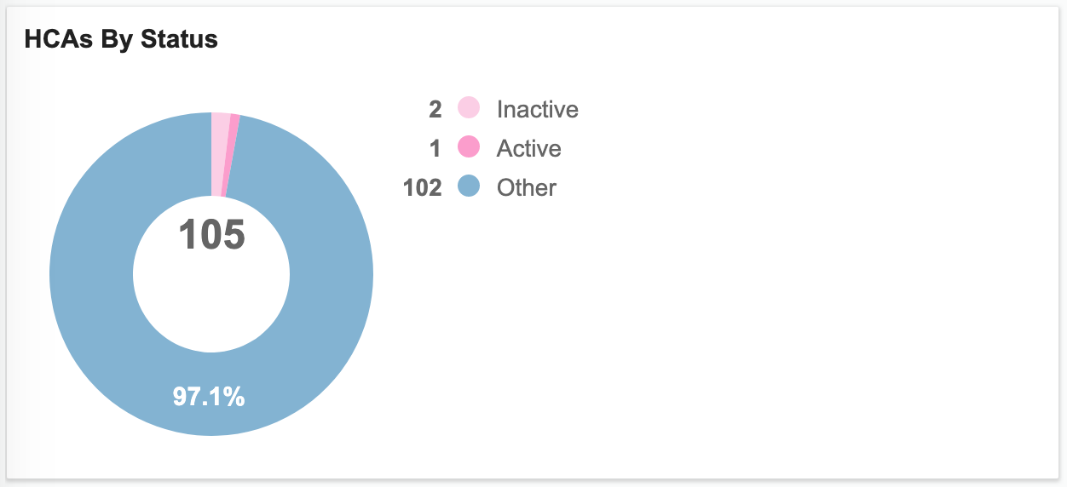

Simple Map View

Simple Map View is a view with facet values on a map chart. It is more customizable in terms of what it can display than MapView, but it does not support federal structure levels, it merely shows a single level which is fed to it via topojson files.

Properties
Name | Type | Description
point | String | "com.reltio.plugins.ui.view".
id | String | unique extension id. Example: "com.reltio.plugins.dashboard.SimpleMapView".
class | String | "com.reltio.plugins.dashboard.SimpleMapView".
map | String | URL to map file.
entity | String | entity type URI. Chart is made for this type. Example: "configuration/entityTypes/HCP".
attribute | String | id ("attributes.[attributeName]"). Example: "attributes.Address.StateProvince".
height | Number | height of a view (optional, default value: 300).
filter | Array.<Object> | filter configuration (optional). Example:  [{  "type": "equals",  "attribute": "attributes.Phone.ValidationStatus",  "value": "VALID"  }]  Name Type Description  type String filter function (standard filters can be used). Example: "equals". "not equals", "missing"  attribute String attribute id ("attributes.[attributeName]"). Example: "attributes.Phone.ValidationStatus".  value String | Number |Boolean attribute value. Example: "VALID".
count | Number | number of elements on chart (optional, default value: 100).
options |  | chart options, see description below (optional).
presentation | Object | configuration of attribute value presentation (optional).  Name Type Description  format String specify attribute formatting. The only possible format now is "none".
caption | String | view's title on view's header (optional).

Chart Options

Name | Type | Description
chartId | String | chart type. Options:  - "BarChart": simple bar chart is designed to work with 2-dimensional datasets, where each item should have unique firstDimension value. If the firstDimension is non-unique across items, then the integration occurs.  - "BarChartGrouped": BarChart with groups.  - "BarChartHorizontal": BarChartGrouped with horizontal bars.  - "LineChart": same as BarChart, but represents data with line chart.  - "Map": map view.  - "Pie": pie chart.
width | Number | the width of the area in pixels, this includes everything - the chart itself, its legend, etc. (optional)
height | Number | the height of the area in pixels, this includes everything - the chart itself, its legend, etc. (optional)
chartWidth | Number | area which is to be occupied solely by chart (optional).
chartHeight | Number | area which is to be occupied solely by chart (optional).
chartPadding | Object | padding inside the Chart Client area (optional). Top padding is used to fit bar super-scripts. Example: {"top": 20, "right": 0, "bottom": 45, "left": 40}.  Name Type Description  top Number chart's top padding.  right Number chart's right padding.  bottom Number chart's bottom padding.  left Number chart's left padding.
minColumnWidth | Number | If you specify this parameter, the column width will be restricted. If you do not specify it, the column width is to be picked automatically which ensures that entire dataset is fit into visible area. Example: 24. (optional)
maxColumnWidth | Number | If you specify this parameter, the column width will be restricted. If you do not specify it, the column width is to be picked automatically which ensures that entire dataset is fit into visible area. Example: 24. (optional)
bandSpacing | Number | defines spacing between columns as a fraction of column width. Example: 0.25 (optional)
scaleAlign | String | align on scale. Options: "left", "center". (optional)
allowPan | Boolean | availability of panning function. (optional)
allowNavBar | Boolean | availability of Navigation bar, which may be shown only if the data does not fit into visible area. (optional)
navBarPadding | Object | the Navigation bar client area is positioned straight below the chart, but padding inside of it can be specified. (optional)  Name Type Description  top Number navigation bar's top padding.  right Number navigation bar's right padding.  bottom Number navigation bar's bottom padding.  left Number navigation bar's left padding.
navBarHeight | Number | navigation bar's height (should be the same or bigger than the sum of vertical padings).
showLegend | Boolean | chart's legend (optional).
legendAnchorPoint | Array.<Number> | anchor point for the legend. Make sure it does not overlap the chart, by also specifying chartWidth and chartHeight. Example: [0, 300]. (optional)
legendAlign | String | can be "top" and "middle". If it is set to "middle", the legend's middle vertical point is set to the legendAnchorPoint. If align is "top", the legend is populated from top to bottom, starting at the anchor point. (optional, default value: "top")
legendBulletSize | Number | bullet size and everything to the left from the legend label (if any). (optional)
legendWidth | Number | width of the legend (the height is calculated automatically). (optional)
startColor | String | map palette's start color (optional, default value: "#D6F1FF").
endColor | String | map palette's end color (optional, default value: "#007AC1").
backgroundColor | String | map's background color (optional, default value: "#DDDDED").
strokeColor | String | map's stroke color (optional, default value: "#FFFFFF").
mapFeatureId | String | identifier of the feature in map file (optional, default value: "europe").
geoIdName | String | identifier of the name in map file (optional, default value: "name").

Example
{
"class": "com.reltio.plugins.dashboard.SimpleMapView",
"caption": "Europe Map",
"entity": "configuration/entityTypes/HCP",
"attribute": "attributes.Address.Country",
"map": "https://s3.amazonaws.com/reltio-ui-files/map_resources/eu.json",
"options": {
"chartId": "Map",
"geoIdName": "iso_a2",
"chartPadding": {
"top": 5,
"right": 0,
"bottom": 5,
"left": 15
},
"startColor": "#D6F1FF",
"backgroundColor": "#dddded",
"endColor": "#007ac1",
"chartWidth": 590,
"chartHeight": 400
}
}

